Library Management System
User Manual
Library Management System is a complete web application and collection of programs designed to assist the librarian in administering its executive responsibilities on a day-to-day basis. Also, it operates your library with much more advantages than a traditional library.

Core features are managing books, issuing books, and receiving a book by managing the proper history of the issued books. Also, librarians can track visitor's logs as well. Additionally, the admin user can manage role-based user management.

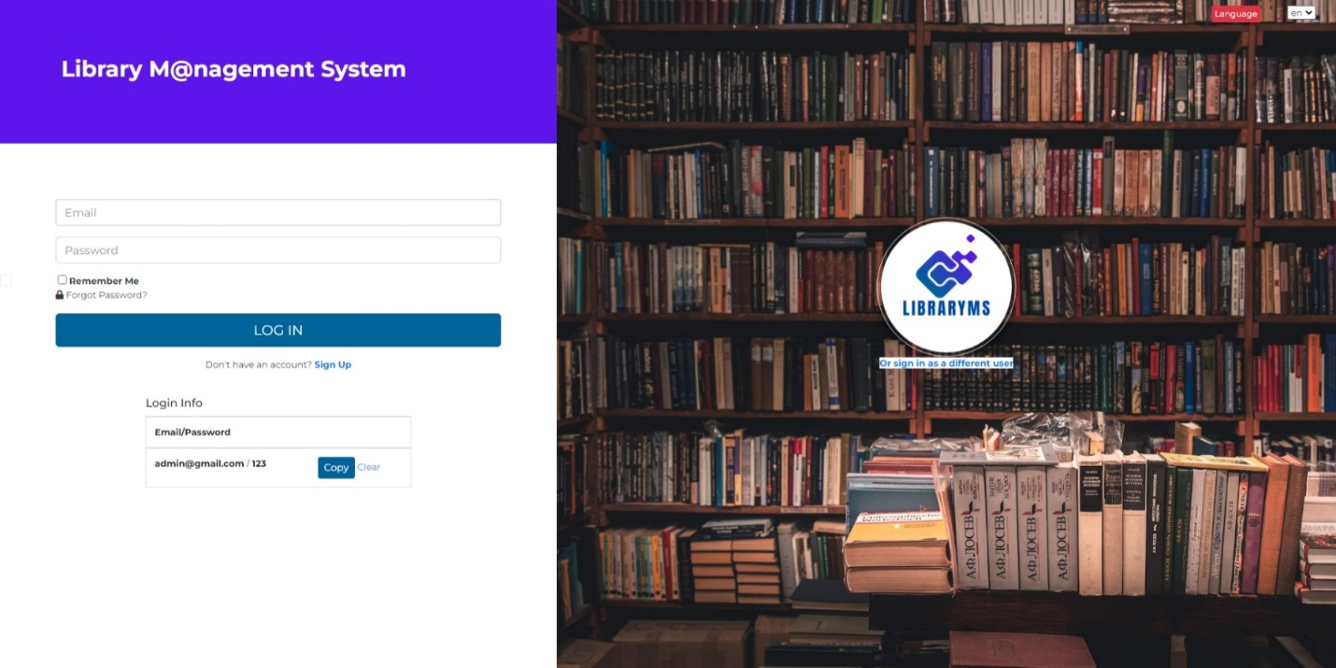

Technical Features
- ASP.NET Core 6.0
- Multi-Language supported
- Dynamic User Role Management
- Audit Logs supported
- EF Core code first
- Identity Core
- MSSQL/MySQL
- Partial page update CRUD operation
- Razor and jQuery for FE
- jQuery DataTable for faster data load
- Sweet Alert2 and Toaster notification
- select2 dropdown
- ASP.NET Core MVC Architecture
- Swagger for API documentation
- Dependency Injection
- Standard Naming conventions
- JWT Token Based Authentication and Claim Based Authorization
- All Methods are Async/Await
- CORS Settings
- Docker Support

Third-Party Plugins:
- Bootstrap and AdminLTE
- Font Awesome
- jQuery
- Select 2
- DataTables (with all exports options)
- daterangepicker
- datepicker
- NToasty
- sweetalert2

Technologies:
Microsoft Visual Studio Community 2022 or later, ASP.NET Core 6.0, Identity Core, Entity Framework Code First, MSSQL SERVER 2017/MySQL, AdminLTE 3.2.0, JavaScript, jQuery data table, bootstrap 4, sweetalert, toastr, Fontawesome etc.

Prerequisite Application:
Microsoft Visual Studio Community 2022 or later, .Net Core 6.0, MS SQL SERVER 2017/MySQL/ PostgreSQL, IIS, Chrome/Edge Browser.

How to run this Project:
Step 1:
Unzip the downloaded zip folder (LibraryMS.zip). Please note that, do not unzip project in such a directory/folder that path contain any space.
Example Wrong Path: C:\User ABC\My Project\ LibraryMS\ LibraryMS
Example Correct Path: E:\gitClone\ LibraryMS\ LibraryMS
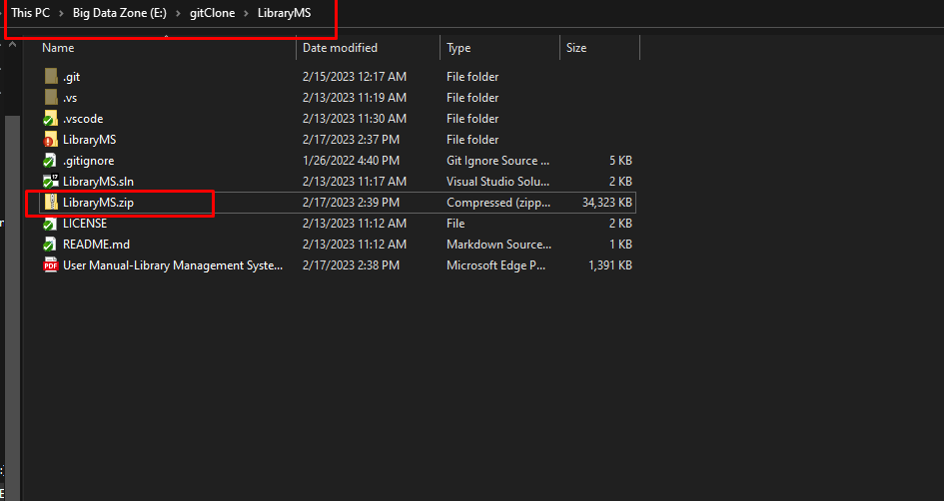

Step 2:
Open LibraryMS.sln file with Visual Studio 2022/VS Code
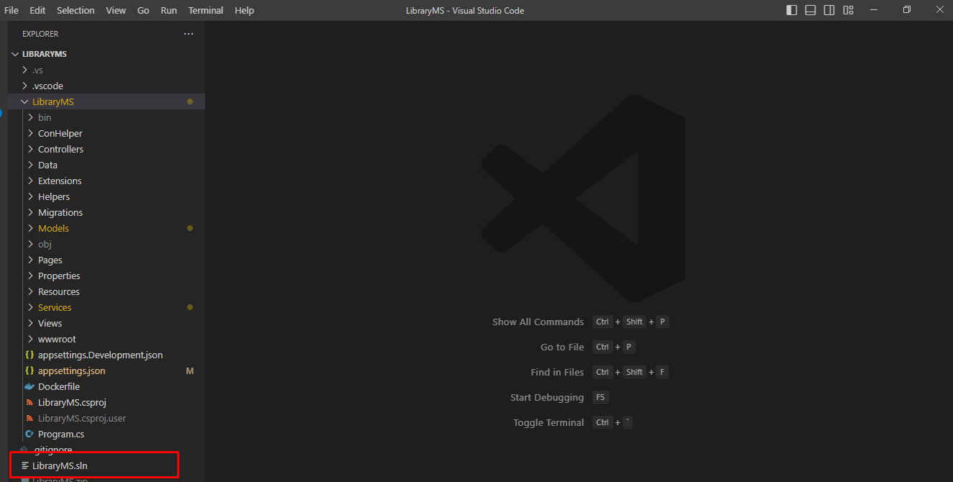
Step 3:
Update database connection: appsettings.json
“connMSSQLNoCred”: “Server=DEVSTATION\\MSSQLSERVER2017; Database= LibraryMS;User ID=sa;Password=dev123456”
Server=Your MSSQL Server Name
User ID= Your MSSQL Server User Name
Password= Your MSSQL Server User Password
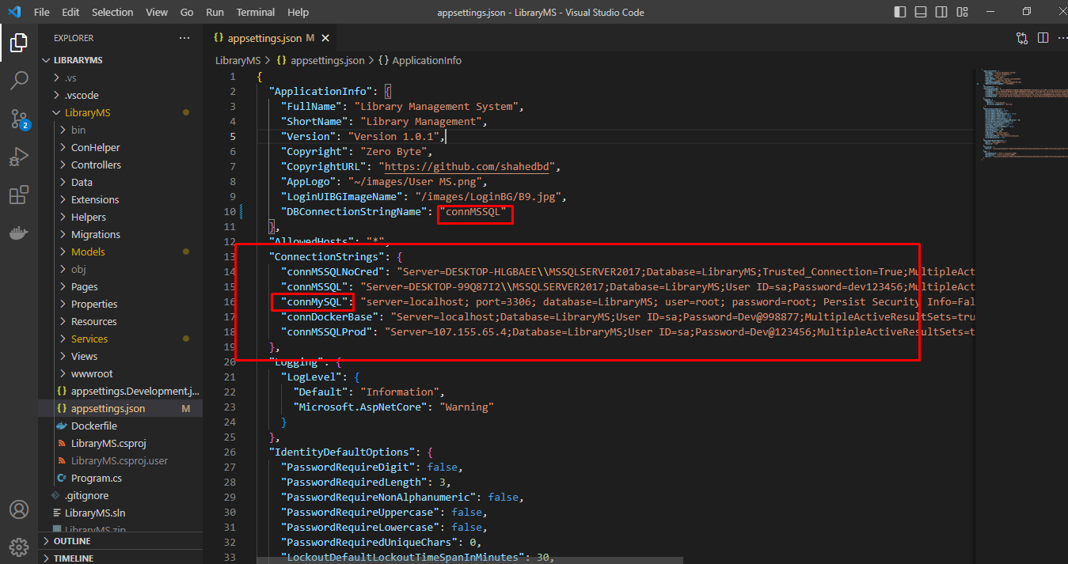

Database Notes:
public const string connMSSQLNoCred = "connMSSQLNoCred";
public const string connMSSQL = "connMSSQL";
public const string connPostgreSQL = "connPostgreSQL";
public const string connMySQL = "connMySQL";
public const string connDockerBase = "connDockerBase";
public const string connMSSQLProd = "connMSSQLProd";
public const string connOthers = "connOthers";
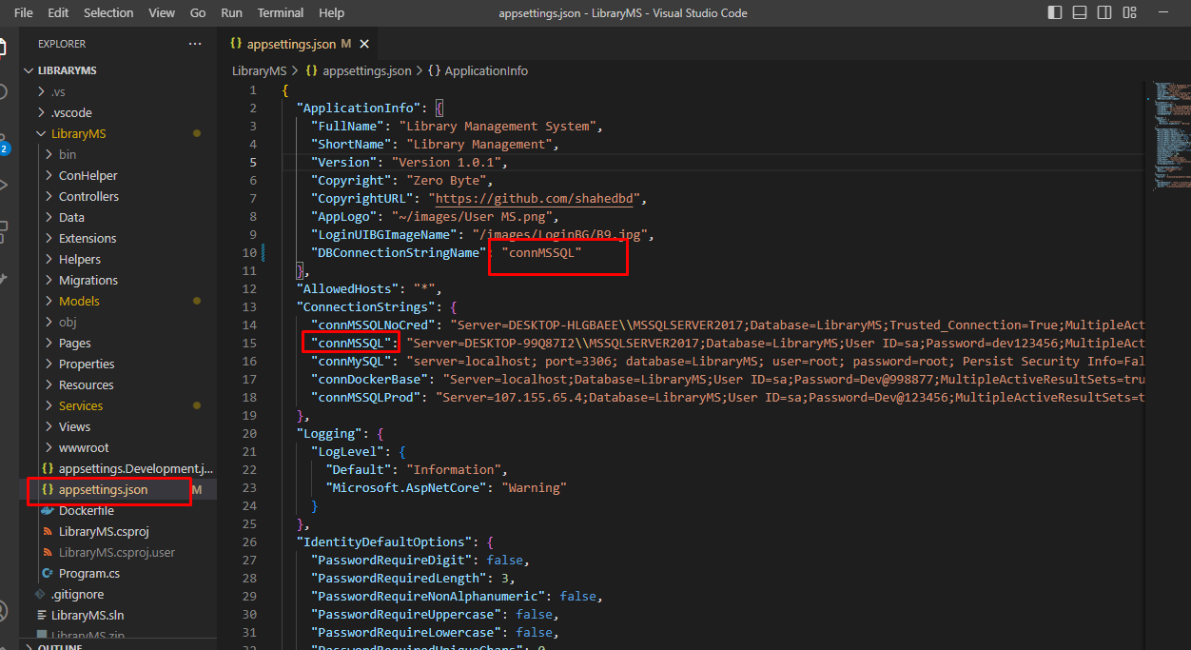

Step 4:
No need to create new migration rule and update database. You just need to build and run the application. Already initial migration rule included with project. Please make sure MS SQL server running properly.
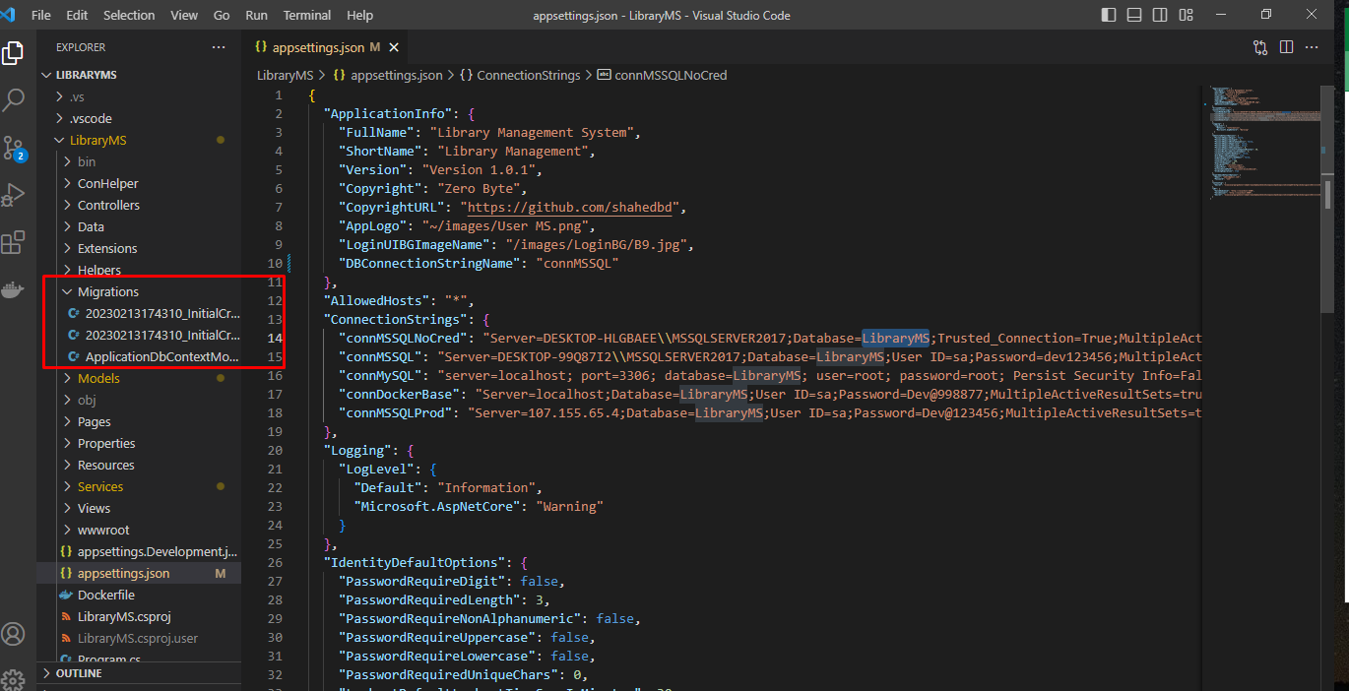

Step 5:
5.1: Build application by pressing f6
5.2: Run application by pressing f5
https://localhost:5027/Account/Login
User Name: admin@gmail.com
Password: 123

Swagger:
http://localhost:5026/swagger/index.html

Initially in the SQL server, relevant tables and data will be created in the database dynamically as code first approach.

Step 6:
Browse full application

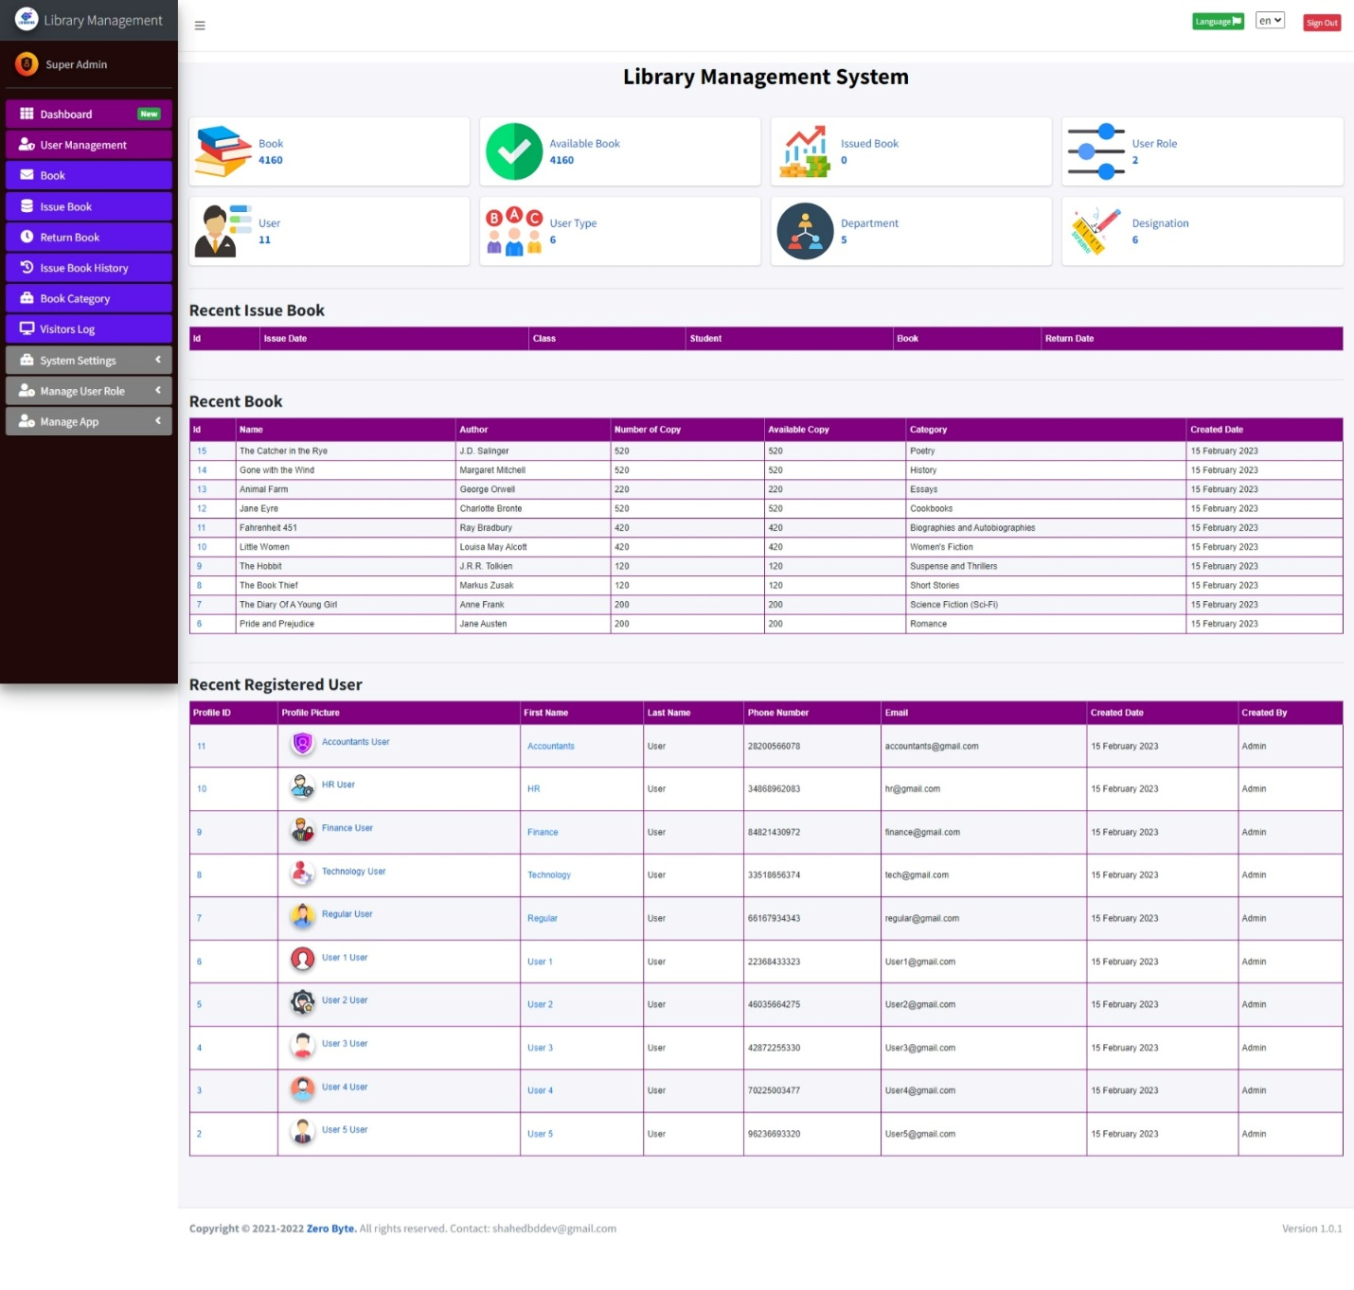
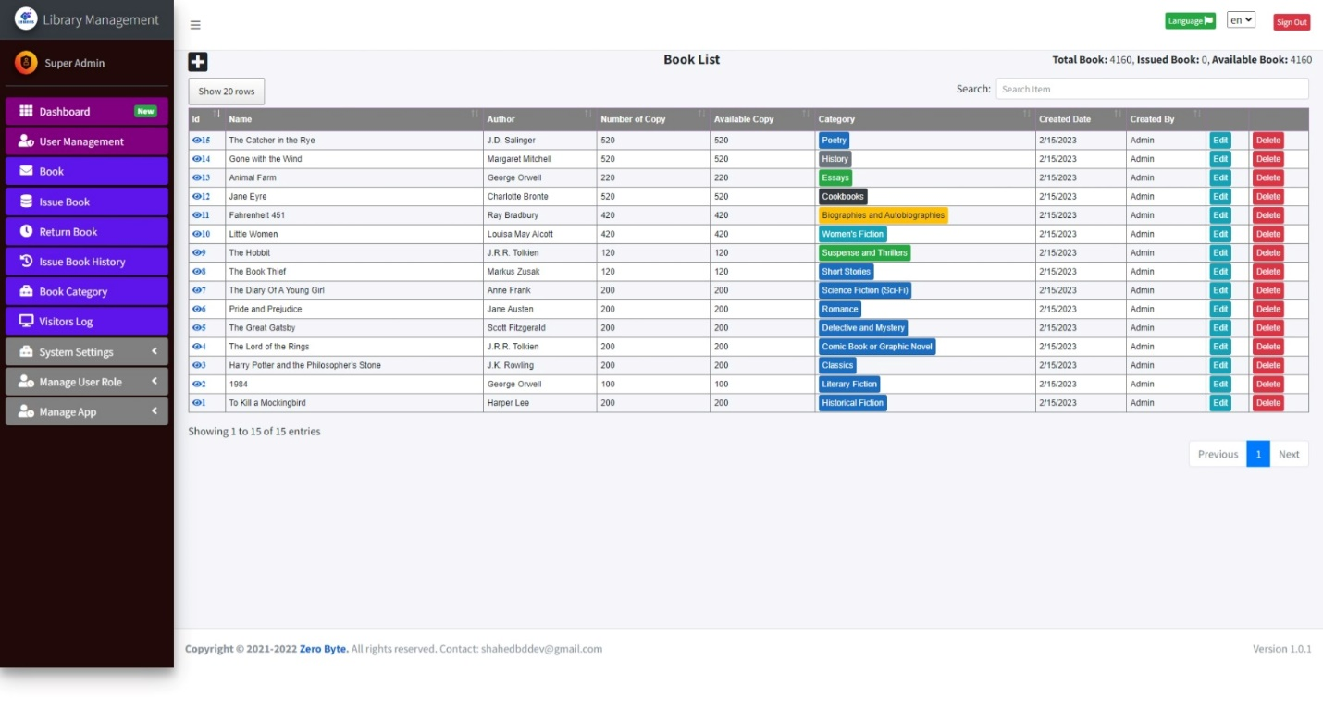

Demo Video:
https://www.youtube.com/watch?v=iJ9VqdgQ0tA

App Screenshot:
https://photos.app.goo.gl/sb1XgWtdHZLhhXW39

DB Migration:
Tools--> Nuget Package Manager--> Package Manager Console

PM> add-migration initcreate
PM> update-database

Check .Net Version:
Press Windows + R.
Type cmd.
On the command prompt, type dotnet --version

FAQ:
Question: How to install Database/How to run migration/Database table not creating?
Answer: Please follow these steps,
1. Make sure the right database connection is in the appsettings.json file
2. Check your server name, by running this SQL: SELECT @@SERVERNAME AS 'Server Name'
3. Delete the database from your SQL Management Studio (if already created)
4. Just build the project (As we have already included Migrations in the project)
5. Run the project
6. Now check your DB. Hopefully, DB and all tables you will find now.
Please cross-check, Program.cs and appsettings.json files properly.

appsettings.json
"DefaultConnectionMSSQL": "Server=DEVSTATION\\MSSQLSERVER2017;Database=LibraryMS;User ID=sa;Password=dev123456;MultipleActiveResultSets=true",
Note that,
Server = your local server
Database = any name
User ID=your local MSSQL Server user name
Password=your local MSSQL Server user password

Required Application:
- Visual Studio 2022
- MSSQ 2017/later
- Dotnet SDK 6.0

Our Product:
SL | Product
1 | Advance POS System with Stock Manager | ASP.NET Core | EF Core | .NET Core 6.0
2 | Asset Management System with Barcode | ASP.NET Core | EF Core | .NET Core 6.0
3 | Hospital and Pharmacy Management System | ASP.NET Core | EF Core
4 | ASP.NET Core full CRUD with .NET 5 | MSSQL/MySQL | EF code first
5 | Inventory and User Management System
6 | Invoice Gen(Invoice Generation and Management) using .Net Core and EF
7 | Complaint | Issue | Helpdesk Ticket | My Ticket HelpDesk Support System | ASP.NET Core | EF Core
8 | Advanced Files & Users Management | ASP.NET Core | EF Core | .NET Core | MSSQL | MySQL
9 | User Management
10 | Business ERP Solution/Product/POS/Company Management
11 | School/College/University Management ERP
12 | ASP.NET Core CRUD Operation Using Dot Net 6.0 | MVC| MSSQL | MySQL | EF Core Code First | jQuery

Tutorials Video:
How to deploy/host ASP.NET Core 6.0 MVC App to IIS Using VS Code | Visual Studio
How to Install Microsoft SQL Server 2019 and SSMS on Windows 10 | Windows 11| Step By Step

Our YouTube Channel
Supports:
If you want to modify or add new features, or any technical issues you have faced during installation you can always contact us at, shahedbddev@gmail.com
WhatsApp: 8801674411603
Telegram: shahed71bd
Skype: shahedatomap
Email: shahedbddev@gmail.com

